Solution of Assignment 1

1. For the Ex 1-13 on p24, answer to the following questions by using R.

a) Use class intervals 10-<20, 20-<30, $⋯$ to construct a histogram of the original data (IDT).

> hist(data$IDT, breaks=seq(10,80,10))

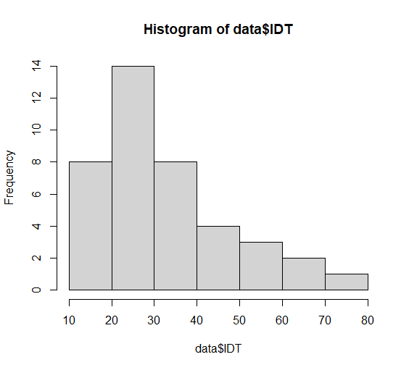

b) Use intervals 1.1-<1.2, 1.2-<1.3, $⋯$ to do the same for the transformed data. $\log_{01}(IDT)$

> hist(data$log10.IDT, breaks=seq(1.1,1.9,0.1))

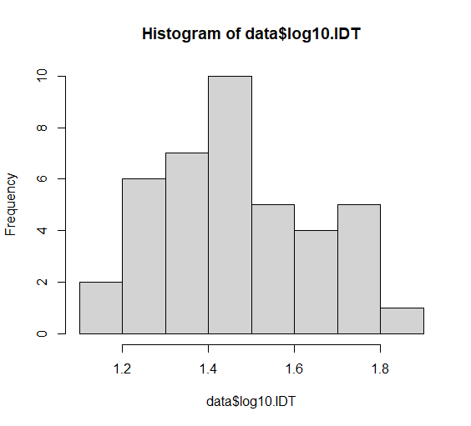

c) Draw the stem and leaf graph for log10.IDT variable

d) Draw the box plot for IDT variable.

> boxplot(data$IDT)

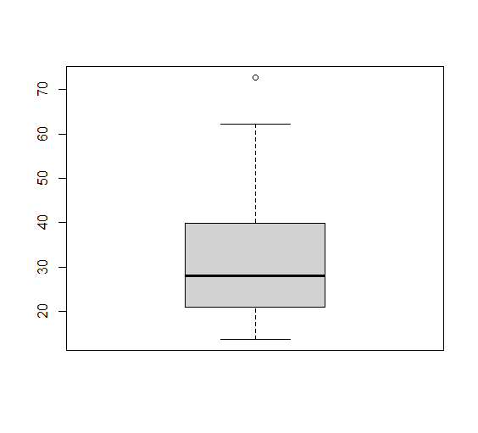

2, a)

Sample mean : $\overline{x}$ = $\frac{\sum_{i=1}^{n}{x_{i}}}{n}=\frac{2563}{19}=134.89$

Sample variance : $s^{2}$ = $\frac{\sum_{i=1}^{n}{{\left(x_{i}-\overline{x}\right)}^{2}}}{n-1}=\frac{22765.79}{18}=1264.77$

Sample standard deviation : $s=\sqrt{s^{2}}=\sqrt{1264.77}=35.56$

Sort :

87 87 93 99 103 105 119 129 130 132 138 145 145 152 153 160 180 195 211

Number of data : 19

Median : 10th number : 132

b) $y_{i}=cx_{i}=\frac{1}{60}x_{i}$: $c=\frac{1}{60}$

sample mean : $\overline{y}=c\overline{x}=\frac{1}{60}\overline{x}=\frac{1}{60}×134.89=2.248$

sample variance : $s_{y}^{2}={c^{2}s}_{x}^{2}={\left(\frac{1}{60}\right)}^{2}×1264.77=0.3513$

sample standard devation : $s_{y}=cs_{x}=\frac{1}{60}×35.56=0.5927$

3.

a. $P{(A}_{1}{⋃A}_{2}$)= $P{(A}_{1}$)+ $P{(A}_{2}$)- $P\left(A_{1}∩A_{2}\right)$ =0.2+0.25-0.11=0.34

b. $P\left(A_{1}'∩A_{2}'\right)=$ P(${(A}_{1}{⋃A}_{2})'$)=1- $P{(A}_{1}{⋃A}_{2}$)=1-0.34=0.66

c. $P{(A}_{1}{⋃A}_{2}⋃A_{3}$)= $P\left(A_{1}\right)+ P\left(A_{2} \right)+ P\left(A_{3}\right)-P\left(A_{1}∩A_{2}\right)-P\left(A_{1}∩A_{3}\right)-P\left(A_{2}∩A_{3}\right)+P\left(A_{1}∩A_{2}∩A_{3}\right)$

=0.2+0.25+0.25-0.11-0.05-0.07+0.01=0.48

d. $P\left({A'}_{1}∩{A'}_{2}⋂{A'}_{3}\right)$ =1- $P{(A}_{1}{⋃A}_{2}⋃A_{3}$)=1-0.48=0.52

e. $P\left({A'}_{1}∩{A'}_{2}⋂A_{3}\right)=P\left(A_{3}\right)-P\left(A_{1}∩A_{3}\right)-P\left(A_{2}∩A_{3}\right)+P\left(A_{1}∩A_{2}∩A_{3}\right)$

=0.25-0.05-0.07+0.01=0.14

f. $P\left(({A^{'}}_{1}∩{A^{'}}_{2})⋃A_{3}\right)=P\left(A_{1}'∩A_{2}'\right)+P\left(A_{1}∩A_{3}\right)+P\left(A_{2}∩A_{3}\right)-\left(A_{1}∩A_{2}∩A_{3}\right)$

=0.66+0.05+0.07-0.01=0.77

4.

a. What is the probability that the next customer will request plus gas and fill the tank ($A_{2}∩B$)

$$P\left(A_{1}\right)=0.45$$

$$P(A_{2} )=0.35$$

$$P\left(A_{3}\right)=0.2$$

$P\left(A_{1}⋂B\right)=0.$ 45\*0.3=0.135

$P\left(A_{2}⋂B\right)=0.$ 35\*0.6=0.21

$P\left(A_{3}⋂B\right)=0.$ 2\*0.4=0.08

So, the probability that the next customer will request plus gas and fill the tank is 0.21.

b. What is the probability that the next customer fills the tank?

P(B)= $P\left(A_{1}⋂B\right)+P\left(A_{2}⋂B\right)+P\left(A_{3}⋂B\right)=0.425$

c. If the next customer fills the tank, what is the probability that regular gas is requested? Plus? Premium?

the probability that regular gas is requested= $P\left(A_{1}⋂B\right)/P(B)$ = 0.135/0.425= 0.3176

the probability that plus gas is requested= $P\left(A_{2}⋂B\right)/P(B)$ = 0.21/0.425= 0.4941

the probability that premium gas is requested= $P\left(A_{3}⋂B\right)/P(B)$ = 0.08/0.425= 0.1882

5.

Let’s suppose that an event that a purchaser purchases basic model is event B, that a purchaser purchases deluxe model is event D and that a purchaser purchases an extended warranty, event W.

Probability that the purchaser bought basic model= $P(B)$*=0.4*

Probability that the purchaser bought deluxe model*= $P(D)$ =1- $P(B)$ =1-0.4=0.6*

Probability that a purchaser who bought a basic model purchased an extended warranty is $P\left(B⋂W\right)$,

and for a case if the purchaser bought deluxe, $P\left(D⋂W\right)$.

$$P\left(B⋂W\right)=0.4*0.3=0.12$$

$$P\left(D⋂W\right)=0.6*0.5=0.3$$

$$P\left(W\right)=P\left(B⋂W\right)+P\left(D⋂W\right)=0.12+0.3=0.42$$

The probability that someone randomly selected purchased basic model when he or she has an extended warranty is

$$\frac{P\left(B⋂W\right)}{P\left(W\right)}=\frac{0.12}{0.42}=0.2857$$

The answer is 0.2857.

6.

Subsystem A : 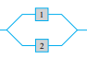

Subsystem B : 

P(Subsystem A works) = $1-\left(1-0.9\right)×(1-0.9)=0.99$

P(Subsystem B works) = $0.9×0.9=0.81$

P(System works) = 1 – P(Subsystem A fails) $×$ P(Subsystem B fails)

= $1-\left(1-0.99\right)×\left(1-0.81\right)=0.9981$

7.

Let $A_{1}$ be the event that the first component function and $A_{2}$ be the event that the second component function

P($A_{1}$)=?

P($A_{2}$)=0.8

P($A_{1}⋂A_{2}$)=0.65

P($A_{1}∪A_{2}$)=0.96

P($A_{1}∪A_{2}$)=0.96 = P($A_{1})$ +P($A_{2})$- P($A_{1}⋂A_{2})$ = P($A_{1})$ +0.8-0.65 $→$ P($A_{1})$ =0.81.

Therefore, $P(A_{2}|A_{1})=\frac{{P(A}_{1}⋂A_{2})}{P(A_{1})}$ = $\frac{0.65}{0.61}=0.8025$